**EMBEDDED SYSTEMS**

Embedded system is basically the study of how to setup a device that is hardware or software or both that is embedded in a larger system and is mostly a real time system. An embedded system usually consists of a microcontroller programmed to do a specific job.

Internet of things is how these devices communicate with each other directly and indirectly to serve a specific purpose. Directly is when two devices or more talk peer to peer. And decide actions based on what the other device says. Indirect is when all of these devices are connected to a single node and the node receives and transmits signals to the devices and intercommunicate is thus established.

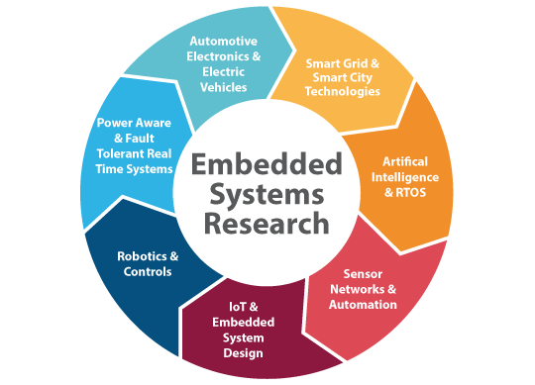

Figure 1.1: Embedded systems

**Core of Embedded Systems**

Embedded systems are domain and application specific and are built around a central core. The core of the embedded system falls into any of the following categories:

**General purpose and Domain Specific Processors**

Almost 80% of the embedded systems are processor/ controller based.

The processor may be microprocessor or a microcontroller or digital signal processor, depending on the domain and application.

**Microprocessors:**

A microprocessor is a silicon chip representing a central processing unit. A microprocessor is a dependent unit and it requires the combination of other hardware like memory, timer unit, and interruptscontroller, etc. for proper functioning. Architectures used for processor design are Harvard or Von-Neumann.

**Microcontrollers:**

A microcontroller is a highly integrated chip that contains a CPU, scratch pad RAM, special and general purpose register arrays, on chip ROM/FLASH memory for program storage, timer and interrupt control units and dedicated I/O ports. Microcontrollers comprise the main elements of a small computer system on a single chip. They contain the memory, and IO as well as the CPU one the same chip. This considerably reduces the size, making them ideal for small embedded systems, but means that there are compromises in terms of performance and flexibility.

Microcontrollers are often intended for low power and low processing applications, some microcontrollers may only use 4 bit words and they may also operate with very low clock rates - some 10 kHz and less to conserve power. This means that some MCUs may only consume a mill watt or so and they may also have sleep consumption levels of a few nano watts. At the other end of the scale some MCUs may need much higher levels of performance and may have very much higher clock speeds and power consumption

Texas Instrument’s TMS 1000 is considered as the world’s first microcontroller. Some embedded system application require only 8 bit controllers whereas some requiring superior performance and computational needs demand 16/32 bit controllers.

The instruction set of a microcontroller can be RISC or CISC.

Microcontrollers are designed for either general purpose application requirement or domain specific application requirement.

**CISC:**

Stands for "Complex Instruction Set Computing." This is a type of design in which the CISC architecture contains a large set of computer instructions that range from very simple to very complex and specialized. Though the design was intended to compute complex instructions in the most efficient way, it was later found that many small, short instructions could compute complex instructions more efficiently. This led to a design called Reduced Instruction Set Computing (RISC), which is now the other major kind of architecture. Intel Pentium processors are mainly CISC-based, with some RISC facilities built into them, whereas the PowerPC processors are completely RISC-based.

**RISC:**

RISC (reduced instruction set computer) is a [microprocessor](https://www.google.com/url?q=https%3A%2F%2Fwhatis.techtarget.com%2Fdefinition%2Fmicroprocessor-logic-chip&sa=D&sntz=1&usg=AFQjCNFF0vcH4WjjXmYSEWh_rv4Rqf0zXg) that is designed to perform a smaller number of types of computer [instruction](https://www.google.com/url?q=https%3A%2F%2Fwhatis.techtarget.com%2Fdefinition%2Finstruction&sa=D&sntz=1&usg=AFQjCNGVOUv1Srzm2mIXjKo_3qAWihOzEw)s so that it can operate at a higher speed (perform more millions of instructions per second, or [MIPS](https://www.google.com/url?q=https%3A%2F%2Fsearchitoperations.techtarget.com%2Fdefinition%2FMIPS-million-instructions-per-second&sa=D&sntz=1&usg=AFQjCNGEAWqMUQp-6hRHyI7YWahpjxDgrQ)). Since each instruction type that a computer must perform requires additional transistors and circuitry, a larger list or set of computer instructions tends to make the working more complicated and slower in operation.

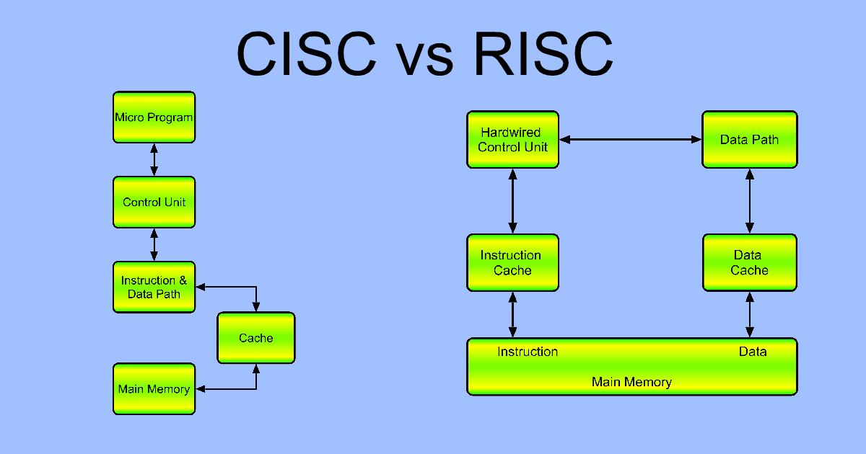

Figure 1.2: Block diagram of CISC and RISC.

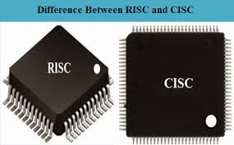

Figure 1.3: CISC and RISC

# ARM:

An ARM processor is one of a family of [CPUs](https://whatis.techtarget.com/definition/processor) based on the [RISC](https://search400.techtarget.com/definition/RISC) (reduced instruction set computer) architecture developed by Advanced RISC Machines (ARM).

ARM makes 32-bit and [64-bit](https://searchdatacenter.techtarget.com/definition/64-bit-processor) RISC [multi-core processors](https://searchdatacenter.techtarget.com/definition/multi-core-processor). RISC [processors](https://whatis.techtarget.com/definition/microprocessor-logic-chip) are designed to perform a smaller number of types of computer [instructions](https://whatis.techtarget.com/definition/instruction) so that they can operate at a higher speed, performing more millions of instructions per second ([MIPS](https://searchitoperations.techtarget.com/definition/MIPS-million-instructions-per-second)).  By stripping out unneeded instructions and optimizing pathways, RISC processors provide outstanding performance at a fraction of the power demand of [CISC](https://whatis.techtarget.com/definition/CISC-complex-instruction-set-computer-or-computing) (complex instruction set computing) devices.

ARM processors are extensively used in consumer electronic devices such as [smart phones](https://searchmobilecomputing.techtarget.com/definition/smartphone), [tablets](https://searchmobilecomputing.techtarget.com/definition/tablet-PC), multimedia players and other mobile devices, such as [wearables](https://internetofthingsagenda.techtarget.com/definition/wearable-computer). Because of their reduced [instruction set](https://whatis.techtarget.com/definition/instruction-set), they require fewer [transistors](https://whatis.techtarget.com/definition/transistor), which enable a smaller die size for the integrated circuitry ([IC](https://whatis.techtarget.com/definition/integrated-circuit-IC)). The ARM processors smaller size reduced complexity and lower power consumption makes them suitable for increasingly miniaturized devices. The simplified design of ARM processors enables more efficient multi-core processing and easier coding for developers.

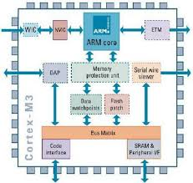

Figure 1.4: ARM Block Diagram

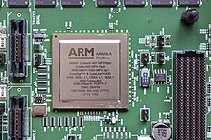

Figure 1.5: ARM processor

**ARM processor features include:**

* Load/store architecture.
* An [orthogonal](https://searchstorage.techtarget.com/definition/orthogonal) instruction set.
* Mostly single-cycle execution.
* Enhanced power-saving design.
* 64 and 32-bit execution states for scalable high performance.
* [Hardware virtualization](https://searchservervirtualization.techtarget.com/definition/hardware-virtualization) support.

**DSP:**

A digital signal processor (DSP) (or a [SIP block](https://www.google.com/url?q=https%3A%2F%2Fen.wikipedia.org%2Fwiki%2FSystem_in_package&sa=D&sntz=1&usg=AFQjCNEerBSYJiX1ClOhOURreKZRrhzwtA)) is optimized for the operational needs of [digital signal processing](https://www.google.com/url?q=https%3A%2F%2Fen.wikipedia.org%2Fwiki%2FDigital_signal_processing&sa=D&sntz=1&usg=AFQjCNEb2Ch_wVDUIEgZzBdJYbZQofZang).[[1]](https://www.google.com/url?q=https%3A%2F%2Fen.wikipedia.org%2Fwiki%2FDigital_signal_processor%23cite_note-1&sa=D&sntz=1&usg=AFQjCNFXmJJ-FO3U67SL1xI__xORceM84Q)[[2]](https://www.google.com/url?q=https%3A%2F%2Fen.wikipedia.org%2Fwiki%2FDigital_signal_processor%23cite_note-Liptak-2&sa=D&sntz=1&usg=AFQjCNH8Y75FNY5zz8kpH44zAktHqFz95Q)

The goal of DSP is usually to measure, filter or compress continuous real-world [analog signals](https://www.google.com/url?q=https%3A%2F%2Fen.wikipedia.org%2Fwiki%2FAnalog_signals&sa=D&sntz=1&usg=AFQjCNEqtq8vYk1bJf4n4QiPPxXJLjEtMA). Most general-purpose microprocessors can also execute digital signal processing algorithms successfully, but may not be able to keep up with such processing continuously in real-time. Also, dedicated DSPs usually have better power efficiency, thus they are more suitable in portable devices such as [mobile phones](https://www.google.com/url?q=https%3A%2F%2Fen.wikipedia.org%2Fwiki%2FMobile_phone&sa=D&sntz=1&usg=AFQjCNHVnzoqi9CkdHgF5OKtP20se4J0dA) because of power consumption constraints.[[3]](https://www.google.com/url?q=https%3A%2F%2Fen.wikipedia.org%2Fwiki%2FDigital_signal_processor%23cite_note-schaum-2004-3&sa=D&sntz=1&usg=AFQjCNG9uozH4ACcu3NzzSBZT1WDhJtCFQ) DSPs often use special [memory architectures](https://www.google.com/url?q=https%3A%2F%2Fen.wikipedia.org%2Fwiki%2FMemory_architecture&sa=D&sntz=1&usg=AFQjCNFy9wT1PUWKauXvRqd-wQMuXCgQ-Q) that are able to fetch multiple data or instructions at the same time.

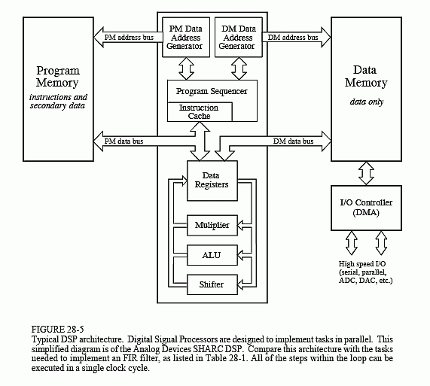

Figure 1.6: DSP Block diagram

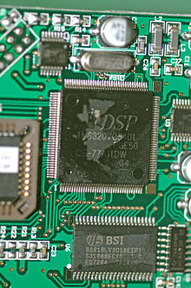

Figure 1.7:  Digital Signal Processors

**Application Specific Integrated Circuits. (ASIC)**

ASICs are a microchip design to perform specific and unique applications.  Because of using single chip for integrates several functions there by reduces the system development cost. It helps in the design of smaller system with high capabilities or functionalities. The developers of such chips may not be interested in revealing the internal detail of it

**Programmable logic devices (PLD’s)**

A PLD is an electronic component. It used to build digital circuits which are reconfigurable.  A logic gate has a fixed function but a PLD does not have a defined function at the time of manufacture.  PLDs offer customers a wide range of logic capacity, features, speed, voltage characteristics. PLDs can be reconfigured to perform any number of functions at any time. A variety of tools are available for the designers of PLDs which are inexpensive and help to develop, simulate and test the designs.

      PLDs having following two major types.

**1) CPLD (Complex Programmable Logic Device):**

CPLDs offer much smaller amount of logic up to 1000 gates.

**2) FPGAs (Field Programmable Gate Arrays):**

It offers highest amount of performance as well as highest logic density, the most features.

**Commercial off-the-shelf components (COTs)**

A Commercial off the Shelf product is one which is used 'as-is'. The COTS components itself may be develop around a general purpose or domain specific processor or an ASICs or a PLDs.

The major advantage of using COTS is that they are readily available in the market, are chip and a developer can cut down his/her development time to a great extent. The major drawback of using COTS components in embedded design is that the manufacturer of the COTS component may withdraw the product or discontinue the production of the COTS at any time if rapid change in technology occurs.

DSP includes following key units:

Program memory: It is a memory for storing the program required by DSP to process the data.

Data memory: It is a working memory for storing temporary variables and data/signal to be processed.

Computational engine: It performs the signal processing in accordance with the stored program memory computational engine incorporated many specialized arithmetic units and each of them operates simultaneously to increase the execution speed. It also includes multiple hardware shifters for shifting operands and saves execution time.

I/O unit: It acts as an interface between the outside world and DSP. It is responsible for capturing signals to be processed and delivering the processed signals.

Examples: Audio video signal processing, telecommunication and multimedia applications.

**SoC:**

A system on a chip or system on chip is an [integrated circuit](https://www.google.com/url?q=https%3A%2F%2Fen.wikipedia.org%2Fwiki%2FIntegrated_circuit&sa=D&sntz=1&usg=AFQjCNEU9phlnsGBUcD1twJiETSUkA_11g) (also known as a "chip") that integrates all components of a [computer](https://www.google.com/url?q=https%3A%2F%2Fen.wikipedia.org%2Fwiki%2FComputer&sa=D&sntz=1&usg=AFQjCNHmXu32vKGipLKVFMDsrpSsRcLaqw) or other [electronic system](https://www.google.com/url?q=https%3A%2F%2Fen.wikipedia.org%2Fwiki%2FElectronics&sa=D&sntz=1&usg=AFQjCNFgXX3muXB6xusy_Zkz2imKP80gIw). These components typically (but not always) include a [central processing unit](https://www.google.com/url?q=https%3A%2F%2Fen.wikipedia.org%2Fwiki%2FCentral_processing_unit&sa=D&sntz=1&usg=AFQjCNHjIxTj_xKCXZCFvx_bd7IOjxWsAQ)(CPU), [memory](https://www.google.com/url?q=https%3A%2F%2Fen.wikipedia.org%2Fwiki%2FComputer_memory&sa=D&sntz=1&usg=AFQjCNFZ0PguVnikXA14_pRDnQ0P0mXbHw), [input/output](https://www.google.com/url?q=https%3A%2F%2Fen.wikipedia.org%2Fwiki%2FInput%2Foutput&sa=D&sntz=1&usg=AFQjCNHvy2tWR_pqzBiac0cYrQIfjt6ZlA) ports and [secondary storage](https://www.google.com/url?q=https%3A%2F%2Fen.wikipedia.org%2Fwiki%2FComputer_data_storage%23Secondary_storage&sa=D&sntz=1&usg=AFQjCNE86LT--WGjV2q9gKw4KkxAMk60aA) – all on a single [substrate](https://www.google.com/url?q=https%3A%2F%2Fen.wikipedia.org%2Fwiki%2FWafer_(electronics)&sa=D&sntz=1&usg=AFQjCNGW2TxcmHqyVjtcf3q8ere2j1kt5w) or microchip, the size of a coin.[[1]](https://www.google.com/url?q=https%3A%2F%2Fen.wikipedia.org%2Fwiki%2FSystem_on_a_chip%23cite_note-2&sa=D&sntz=1&usg=AFQjCNFpAqPPXZhtD98noBe0gIHVnjvrTA) It may contain [digital](https://www.google.com/url?q=https%3A%2F%2Fen.wikipedia.org%2Fwiki%2FDigital_signal_(electronics)&sa=D&sntz=1&usg=AFQjCNHYa6EcmN2y9LIombyti2aHPBz7Pw), [analog](https://www.google.com/url?q=https%3A%2F%2Fen.wikipedia.org%2Fwiki%2FAnalog_signal&sa=D&sntz=1&usg=AFQjCNFRlYrQ5uU_Pgp44MuET11TdKbjOw), [mixed-signal](https://www.google.com/url?q=https%3A%2F%2Fen.wikipedia.org%2Fwiki%2FMixed-signal_integrated_circuit&sa=D&sntz=1&usg=AFQjCNFO28CeutwlREifai-MrNPVenNHHg), and often [radio frequency](https://www.google.com/url?q=https%3A%2F%2Fen.wikipedia.org%2Fwiki%2FRadio_frequency&sa=D&sntz=1&usg=AFQjCNGshrVVm76ubvMxW4Dr4p-PFb8htQ) [signal processing](https://www.google.com/url?q=https%3A%2F%2Fen.wikipedia.org%2Fwiki%2FSignal_processing&sa=D&sntz=1&usg=AFQjCNGyCf7FUhiovT7u4Kc1pBvYjJBWhg) functions, depending on the application. As they are integrated on a single substrate, SoCs consume much less power and take up much less area than multi-chip designs with equivalent functionality. Because of this, SoCs are very common in the [mobile computing](https://www.google.com/url?q=https%3A%2F%2Fen.wikipedia.org%2Fwiki%2FMobile_computing&sa=D&sntz=1&usg=AFQjCNFUIVeZ0a5TKiyMy34yUC_agqSHNg) (such as in [Smart phones](https://www.google.com/url?q=https%3A%2F%2Fen.wikipedia.org%2Fwiki%2FSmartphone&sa=D&sntz=1&usg=AFQjCNHRPMCJ7dCbGEWM_ULYXvWqk6IXQQ)) and [edge computing](https://www.google.com/url?q=https%3A%2F%2Fen.wikipedia.org%2Fwiki%2FEdge_computing&sa=D&sntz=1&usg=AFQjCNEXrsTfWsOyZ5jUShlsjPDfpT8jcA) markets.[[2]](https://www.google.com/url?q=https%3A%2F%2Fen.wikipedia.org%2Fwiki%2FSystem_on_a_chip%23cite_note-3&sa=D&sntz=1&usg=AFQjCNElLxfiODkZgwM0fkNidc5tWw1YKw)[[3]](https://www.google.com/url?q=https%3A%2F%2Fen.wikipedia.org%2Fwiki%2FSystem_on_a_chip%23cite_note-4&sa=D&sntz=1&usg=AFQjCNH1Nclz0l0hkn_m3J-MeYYGh_uTWw) Systems on chip are commonly used in [embedded systems](https://www.google.com/url?q=https%3A%2F%2Fen.wikipedia.org%2Fwiki%2FEmbedded_system&sa=D&sntz=1&usg=AFQjCNGsRXL96_F0W9nYPJTRG_fkn3RnLw) and the [Internet of Things](https://www.google.com/url?q=https%3A%2F%2Fen.wikipedia.org%2Fwiki%2FInternet_of_things&sa=D&sntz=1&usg=AFQjCNFuCONdv8SVMhiVP7aWsDOp_WcjBg).

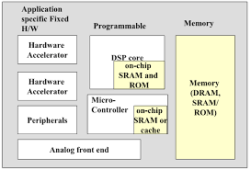

Figure 1.8: SoC Block Diagram.

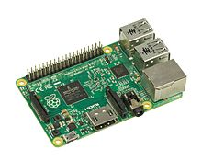

Figure 1.9 : SoC